BEEE LAB EVALUATION

NAME : SANYAM BHAGAT

UID : 19BCS4608

CLASS : IOT (2)

AIM :

9. Design an automatic night lighting system (with 4 connected led’s) such the system is only activated when the master control switch is pressed. a) Below 50% value of full brightness all LED’s constantly ON. b) Above 50% value of full brightness only first LED is ON**.**

APPRATUS :

1. 5 RESISTORS
2. LDR
3. BREADBOARD
4. CONNECTING WIRES
5. 4 LED
6. AUDRINO
7. MASTER SWITCH

CIRCUIT DIAGRAM

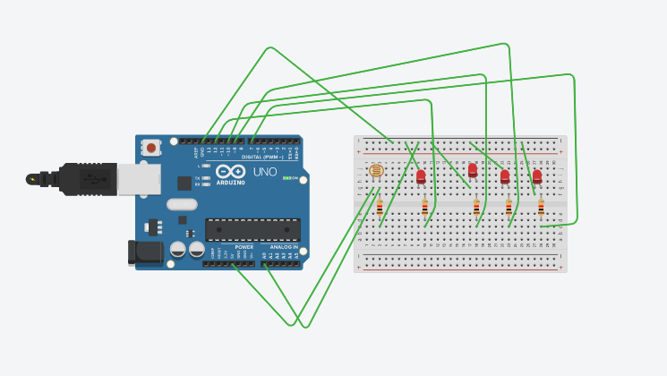

CODE :

int value=0;

void setup()

{

Serial.begin(9600);

pinMode(A0,INPUT);

pinMode(12,OUTPUT);

pinMode(9,OUTPUT);

pinMode(7,OUTPUT);

pinMode(10,OUTPUT);

}

void loop()

{

value=analogRead(A0);

if(value<500)

{

digitalWrite(12,HIGH);

digitalWrite(9,HIGH);

digitalWrite(7,HIGH);

digitalWrite(10,HIGH);

}

else

{

digitalWrite(12,HIGH);

digitalWrite(9,LOW);

digitalWrite(7,LOW);

digitalWrite(10,LOW);

}

}